Assignment 1
Subjekt (grundled) | Verballed (udsagnsled)
1.
2.
3.
4.
5.

Assignment 2
1. | “We’re thrilled that Sephora is the first of the four major retailers…”
Svar:

2. | …the issues won’t be solved overnight.
Svar:

3. | Walmart said it’s made the decision…
Svar:

4. | Walmart doesn’t tolerate discrimination of any kind.
Svar:

5. | …companies can’t just walk the walk anymore.
Svar:

6. | Everything’s under a microscope right now.
Svar:

7. | “Retailers are losing because they’re not identifying people of color…”
Svar:

Assignment 3

Assignment 4
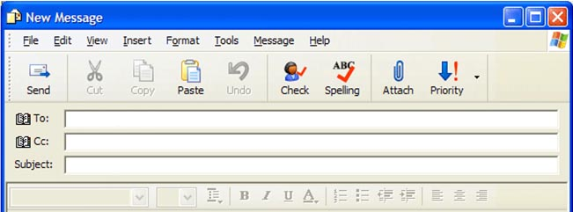

Assignment 5: Retailing and racial inequality in the US

