**Assignment 1**

**Skriv hvilket subjekt (grundled) de otte understregede verballed (udsagnsled) hører til, og angiv om subjektet (grundleddet) står i ental eller flertal.**

*Eksempel:* *Even able-bodied consumers see value in some of the innovations that have resulted, like shoes that zip open in the back.*

|  |  |  |
| --- | --- | --- |
| Verballed (udsagnsled) | Subjekt (grundled) | Singularis (ental) eller Pluralis (flertal) |
| *See* | *consumers* | *Pluralis (flertal)* |

Scheier, who serves as an advisor to Zappos Adaptive, Tommy Adaptive, and other clothing lines, hopes the kind of clothing that suits her son will someday be mainstream. "My goal is to hopefully never have this conversation because it will just be another fit in industry no different from 'plus size,' 'maternity' and 'petite' because these are just different-shaped bodies that require modifications than what already exists," Scheier said.

*Source: For people with disabilities, a trend in “adaptive” clothing*

|  |  |  |
| --- | --- | --- |
| Verballed (udsagnsled) | Subjekt (grundled) | Singularis (ental) eller Pluralis (flertal) |
| 1. serves |  |  |
| 1. hopes |  |  |
| 1. suits |  |  |
| 1. is |  |  |
| 1. are |  |  |
| 1. require |  |  |
| 1. exists |  |  |
| 1. said |  |  |

**Assignment 2**

**Angiv ordklassen for hvert af de understregede adjektiver (tillægsord) eller adverbier (biord) i nedenstående tekststykke. Sæt kryds og angiv hvilke(t) ord i sætningen, det lægger sig til.**

*Eksempel: Americans with disabilities make up the third-largest market segment in the U.S., according to the federal Office of Disability Employment Policy.*

|  |  |  |  |
| --- | --- | --- | --- |
| Det understregede ord | Adjektiv (tillægsord) | Adverbium (biord) | Lægger sig til |
| third-largest | X |  | market segment |

Collectively, they have disposable income of about $490 billion -- that's nearly as much as the purchasing power of each of the top two segments, African-Americans and Hispanics, according to American Institutes for Research (AIR). Yet many mainstream retailers largely ignore them, leaving medical supply companies as the primary source of so-called adaptive clothing.

|  |  |  |  |
| --- | --- | --- | --- |
| Det understregede ord | Adjektiv (tillægsord) | Adverbium (biord) | Lægger sig til |
| 1. |  |  |  |
| 2. |  |  |  |
| 3. |  |  |  |
| 4. |  |  |  |
| 5. |  |  |  |
| 6. |  |  |  |
| 7. |  |  |  |
| 8. |  |  |  |

*Source: For people with disabilities, a trend in “adaptive” clothing*

**Assignment 3**

Skriv en sammenhængende tekst på engelsk (50-75 ord), som beskriver nedenstående foto. I teksten skal alle ordene fra listen nedenfor inddrages i vilkårlig rækkefølge:

**celebrating, wearing, smiling, playing, drinking, advertising**

Ordenes form må ikke ændres.

**I din besvarelse skal du fremhæve de anvendte ord med farve eller fed skrift.**

*Source: Tommy Hilfiger´s spring summer campaign 2011: Meet the Hilfigers at the country club*

|  |
| --- |
| **Assignment 4** |

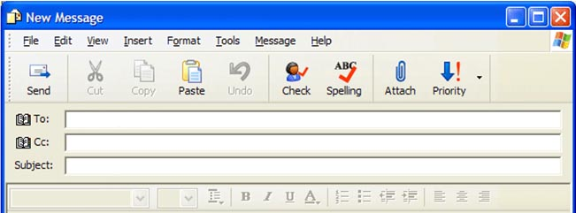

|  |
| --- |
|  |

|  |
| --- |
| **Assignment 5** |