Assignment 1
Omskriv nedenstående 5 sætninger til spørgende sætninger.
Eksempel:

 | Sætning
 | They say their main problem is unreasonable demands from big clients - mainly in the US and the UK.
Svar: | Do they say their main problem is unreasonable demands from big clients - mainly in the US and the UK?

 | Sætning
1. | They are also asking for a 30- to 120-day extension on previously agreed payment terms.
Svar:
2. | The problems started in February when factories couldn't get the raw materials they needed from China…
Svar:
3. | Brands have profited for many years from producing in low wage countries without social security systems.
Svar:
4. | Decades of exploitation must now be paid back to care for their workers.
Svar:
5. | Retailers have to help out.
Svar:

Assignment 2
Indsæt ordet/ordene i parentes, så det/de står på en korrekt placering i nedenstående 6 sætninger.
Eksempel:

 | Sætning | Ord, der skal indsættes i sætningen
 | Without it, he claims, the industry could be wiped out completely… | almost
Svar: | Without it, he claims, the industry could almost be wiped out completely

 | Sætning | Ord, der skal indsættes i sætningen
1. | Coronavirus lockdowns aren’t the only thing affecting their ability to pay their workers. | as a matter of fact
Svar:
2. | ….they could be applying for a bailout from the US government stimulus package… | never
Svar:

3. | They say their main problem is unreasonable demands from big clients. | highly
Svar:

4. | It comes as garment manufacturers have been hit hard by two major issues related to coronavirus lockdowns. | particularly
Svar:

5. | In an email obtained by the BBC, one US retailer has asked for a 30% discount…. | recently
Svar:

6. | Some brands are showing a true sense of partnership… | also
Svar:

Assignment 3

Assignment 4

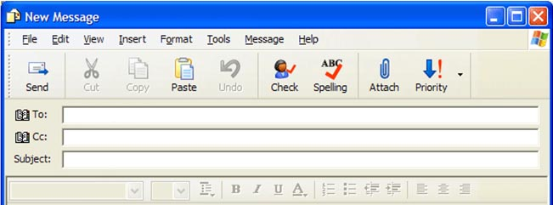

Assignment 5: Fast fashion and the coronavirus crisis

